REGISTER FOR AWS FREE-TIER ACCOUNT
Step 1: First, open your web browser and navigate to the AWS Free Tier Page
Step 2: On the middle click of Create a Free Account
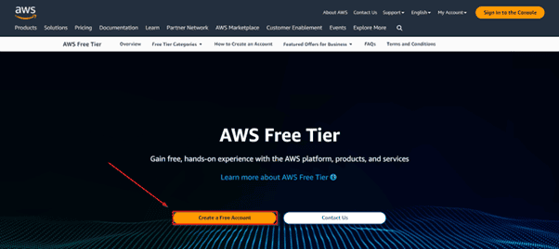
Step 3: Verify your email address.
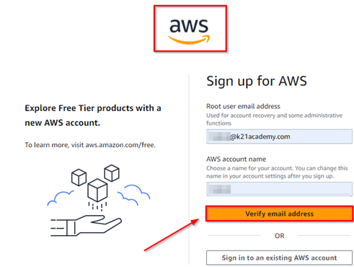
- Provide password: Provide the details that you want to use to log in to your AWS account, and click on Continue
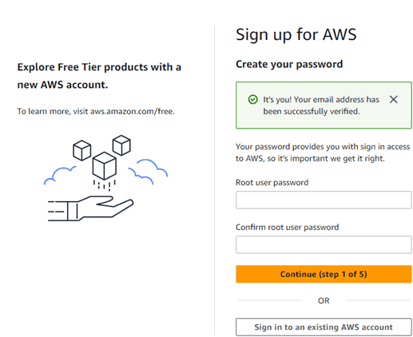
- Email address: Enter the email ID that hasn’t been registered yet with Amazon AWS
- Password: Type your Password
- Confirm password: Confirm the Password
- Captcha: Enter the given security check
AWS offers two plans for new customers: the Free Plan and the Paid Plan. Since we will be building production-ready workloads and using AI/ML services like SageMaker, OpenSearch, and other advanced services, we recommend selecting the Paid Plan.
Paid Plan Benefits:
- Access to over 150 AWS services, including AI/ML, Compute, Databases, Storage, and more.
- Receive up to $200 USD in credits to explore and test services. Gain $100 USD credits at sign-up and up to $100 USD more to earn as you explore key AWS services.
- Enjoy free usage of select services within credit limits.
- Pay only when your usage exceeds the credit thresholds.
- Scale workloads beyond the free-tier limits as your projects grow.
- Full access to all AWS features and services for development, testing, and production environments.
Choosing the Paid Plan ensures you can use all cloud services without limitations. This is essential for AI/ML projects, data engineering, and advanced cloud workloads that may exceed the Free Tier usage limits. It also allows you to develop real-world production-ready applications while still enjoying initial credits.
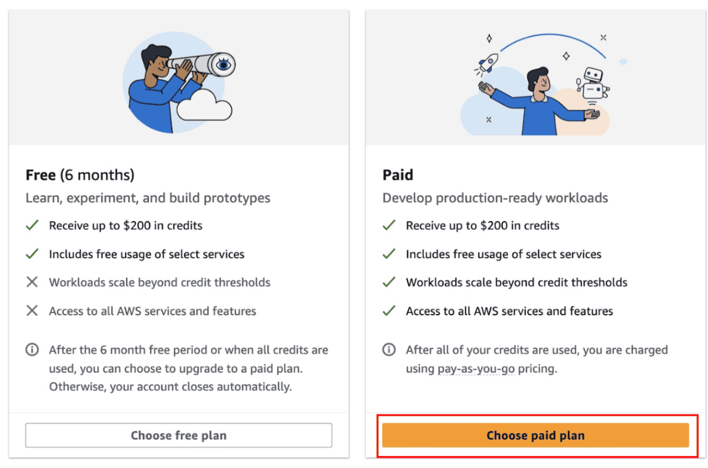
Step 4: Contact Information
Select your AWS type (Professional/ Personal). Fill in the correct information to validate your account if you’re going to create a personal use account, then click on “Personal Account”; otherwise, use “Company Account”, accept the Terms and Conditions, and then click on Create Account and Continue
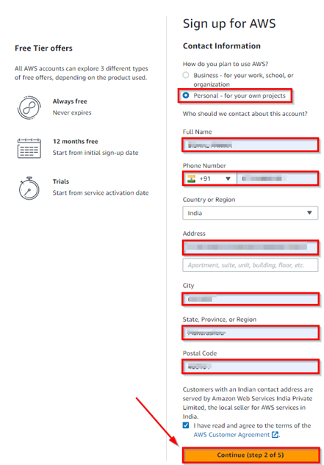
Note: Make sure to provide proper contact details and mobile number to get the Verification code from AWS.
Step 5: Payment and PAN information: In this step, you must fill in your credit card /Debit Card info and billing address and click on Secure Submit.
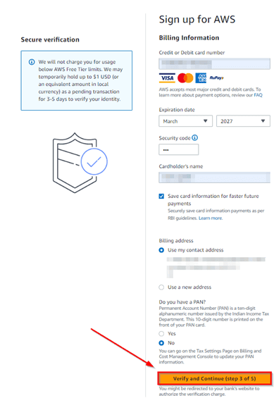
Read AWS CLI Secrets Manager.
Step 6: In this step, it will take you to the payment gateway to validate your payment information, and for your credit card verification, Amazon will charge the minimum price based on your Country. Here I have provided India, so Amazon charged 2 INR.
Step 7: Phone verification: Here, you will be taken to an identity verification page that will already have your phone number, so you just have to select either “Text message or Voice call.” Provide a valid phone number, solve the captcha, and then click on Send SMS or Call Me Now(depending upon your selection).
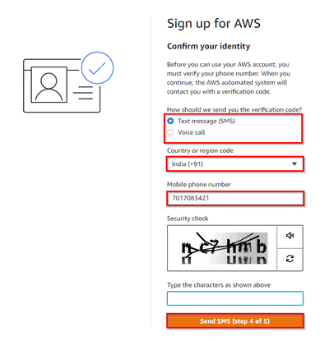
Step 8: After clicking on Send SMS or Call me Now, you will immediately receive a call or SMS from Amazon for a verification code. Enter your code, then click on Verify Code.
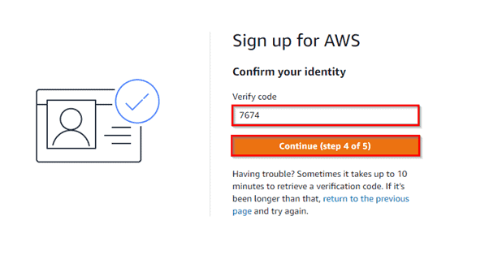
Step 9: Support plan: AWS support offers a selection of plans to meet your business needs.
Select your suitable plan, then click continue.
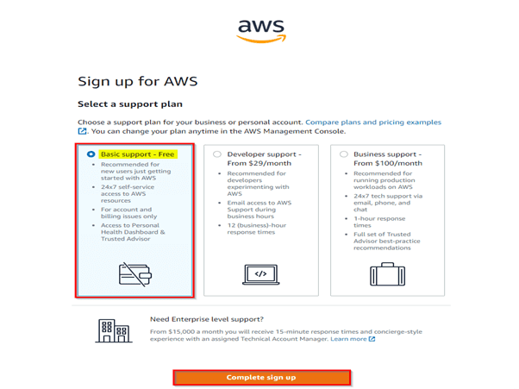
Note: All customers receive free basic support.
Step 10: Registration Confirmation page.
Once you have completed all the above steps and processes. You’ll get the confirmation page below. Now your account will be processed for activation. It may take somewhere between 30 minutes and 1 hour for you to receive an email confirmation that your Amazon Cloud Services account has been activated.
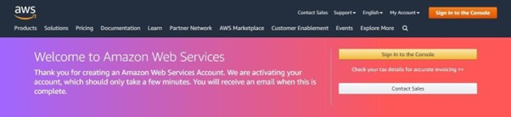

Log in to the AWS Console
Note: Make Sure you log in as the root user in your AWS Account.
Step 1: Open your web browser, navigate to https://aws.amazon.com/console/, and click on Sign In to the console.

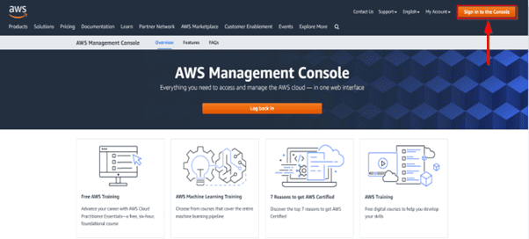
Step 2: Enter the username that you have chosen while creating the account and click on Next.

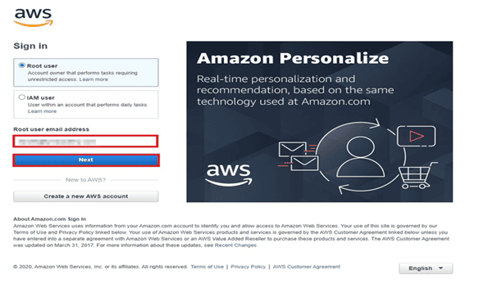
Step 3: Enter the password associated with the user and then click on Sign in.

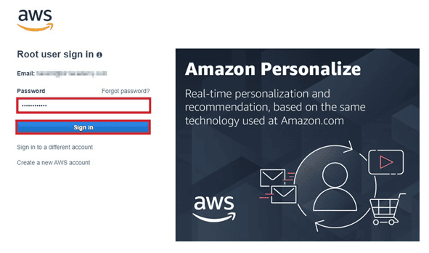
Step 4: You can see the home screen below after you log in.

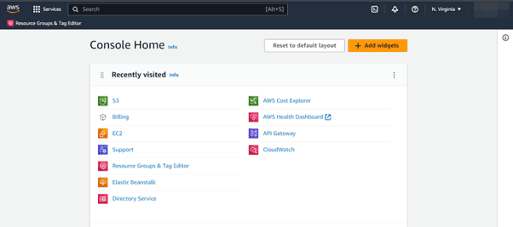

Step-by-Step Guide to Creating an AWS IAM User

Step 1: Log into the AWS Management Console
Head over to the AWS Management Console. You need to sign in as a user with administrative privileges. If this is your first time logging in, you’re likely using the “root” user account, which gives full access to all resources.

Step 2: Navigate to IAM
Once logged in, search for IAM in the AWS services search bar, and click on the IAM service to open the IAM dashboard.

Step 3: Add a New User
In the left-hand menu of the IAM dashboard, click Users and then click the Create user button at the top.
Press enter or click to view image in full size
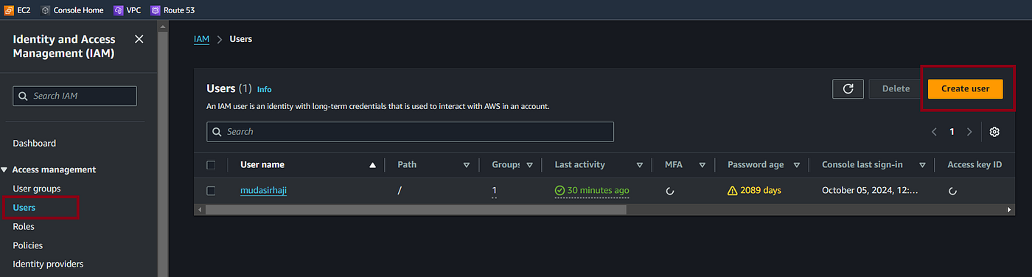
Step 4: Enter User Details
Choose a unique username for the user. This will be used to sign in.
Press enter or click to view image in full size
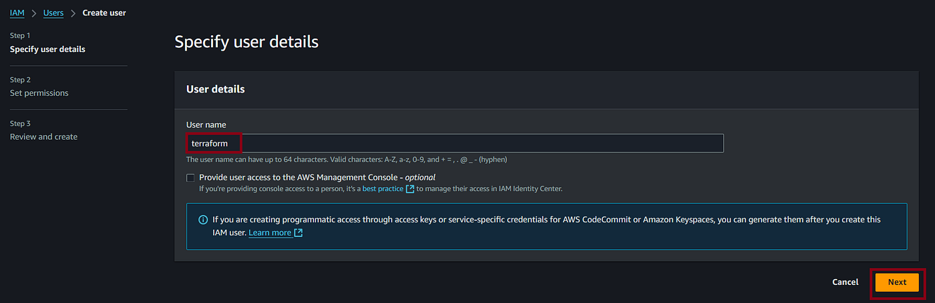

Step 5: Assign Permissions
This step lets you decide the level of access the user will have. You can assign permissions in the following ways:
- Add user to group: If you’ve already set up IAM groups with specific permissions, simply add the user to an appropriate group.
- Copy permissions from existing users: Copy the permissions of a previously created user.
- Attach policies directly: You can attach specific AWS-managed or custom policies directly to the user.

Free Tier Limits
- Monthly 750 hours of Amazon EC2 Cloud computing capability that is scalable.
- 5 GB of basic storage on Amazon S3, Infrastructure for scalable, robust, and secure object storage.
- Monthly database usage allotted to Amazon RDS 750 hours (for relevant database engines), SQL Server, MariaDB, PostgreSQL, and MySQL managed relational database services.
- 5 GB of Amazon EFS storage. A shared file storage solution that is easy to use and scales for Amazon EC2 instances.
- 30 GB of General Purpose (SSD) or Magnetic Elastic Block Storage from Amazon Elastic Store is long-lasting, dependable, low-latency block-level storage volumes for EC2 instances.

